Project: Woodson Park Academy & YMCA-ELC
Week Ending: August 30th, 2019

THIS WEEK:
- Grading continued
- Haul off of rubble and haul in of fill
- French drain installed

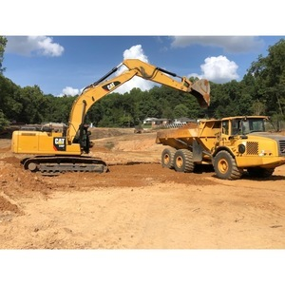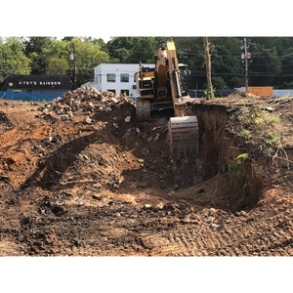

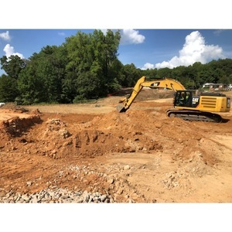

NEXT WEEK – September 2 thru July 6:
- Aggregate piers
- Grading

PAYMENT STATUS:
- Gmp#1 $3,703,488.00
  - Paid to date amount $0.00
- GMP#2 $28,686,295.00
  - Paid to date amount $0.00

SCHEDULED DATE OF SUBSTANTIAL COMPLETION
- WPA – September 28, 2020
- YMCA-ELC - September 16, 2020

PREPARED BY:
- Matt Dauber, Carroll Daniel Construction Co.

